Project Report

|  |  |
| --- | --- |
| Product Name | Advanced Certificate in Web Development |
| Qualification Name (NICF) | NICF-Advanced Certificate in Infocomm Technology (Software & Applications) |
| Product Name | Database Design and Implementation |
| Module Name (NICF) | ITSF-Database Design and Implementation |

|  |  |  |  |
| --- | --- | --- | --- |
| Student name | | Assessor name | |
| Ida Bagus Ketut Yoghantara | |  | |
| Date issued | Completion date | | Submitted on |
| 8 August 2022 | 4 August 2022 | |  |
|  | |  | |
| Project title | Design, Implement, Test & Document Community Portal Database. | | |

|  |
| --- |
| Learner declaration |
| I certify that the work submitted for this assignment is my own and research sources are fully acknowledged.  Student signature:  Date: 2 August 2022 |

Content

1. Project background
2. Project Objectives
3. Database Requirement Specifications
4. Task 1
5. Task 2
6. Task 3
7. Task 4
8. Task 5
9. Task 6

Project Background  
  
ABC Jobs Pte Ltd as a website developer to develop a community portal for Software Developers. The Scope of the Project is to design a Community Portal similar to Linkedin.com. Users will be able to register in the portal using Registration Page. Users of the portal can search for other users using various parameters such as First Name, Last Name, Company Name, City & Country. Users will be able to view the Public Profile of users after searching them.  
  
The portal allow users to login, request for forgotten password and update their profile information. The scope of the project in this module is for development of Databases using MYSQL & My PHP Admin.

Project Objective

## **Project Goal**

* To design the conceptual and entity relationship diagram (ERD) using ERDPlus
* To implement and develop the database using MySQL Workbench
* To conduct functional and non-functional testing on the database
* To create a backup database and using Task Scheduler to run the batch file automatically

## **Scope of the Project**

The scope of this project is to design a community portal similar to Linkedin.com. The website should allow users to register, login, change password, update profile, search and view other users’

## **Tools & Platform**

* MySQL Workbench 8.0

MySQL Workbench is use to implement the database design for the community portal

* Apache 2.4

Apache is a local web server used to access phpMyAdmin portal under localhost

* ERDPlus.com

ERDPlus is used to design the conceptual and entity relationship diagram

* Windows Task Scheduler

Task scheduler is used to run the batch script at a scheduled time for the backup database

* Command Prompt

The command prompt is used to run the command in the batch script and for testing

* Notepad

Database Requirements Specification  
  
1. System Requirement  
 a. Linux  
 b. macOS  
 c. Windows  
  
2. Hardware Requirement  
 Minimum:  
 a. 2 CPU Cores  
 b. 2 GB Ram  
 c. Disk I/O subsystem applicable to a write-intensive database  
   
 Recommended:  
 a. 4 CPU Cores  
 b. 8 GB Ram  
 c. RAID10 or RAID 0+1 disk setup  
  
3. Software Requirement  
 a. MySQL 8.0  
 b. PHP MyAdmin  
 c. Apache 2.4

Task 1

Task Statement:

1. Create a database requirements specification document for the project scenario.
2. Include it as part of Project Report

Solution:

The following shows the database table required for each scenario in the community portal.

|  |  |
| --- | --- |
| Scenario | Database table |
| Registration | Users, User Profile |
| Login | Users, User Profile |
| Forgot Password | Users, User Profile |
| Update Profile | Users, User Profile, Jobs |
| Search User | Users, User Profile |
| Messages | Users, User Profile, Messages, Conversation |
| Create Threads | Users, User Profile, Thread |
| Comment Thread | Users, User Profile, Comments, Thread |
| Post Jobs | Admin, Jobs, Company |
| Administrator | Admin, Users, User Profile, Jobs, Company |
| Send Bulk Email | Admin, Bulk Invite |
| Apply Job | Users, User Profile, Apply Job |

Based on the requirement, the relationship information is:

|  |  |  |  |  |
| --- | --- | --- | --- | --- |
| **No** | **Entity One** | **Entity Two** | **Relationship** | **Note** |
| 1 | Users | User Profile | One to one | One user has one profile page in the portal |
| 2 | User Profile | Jobs | One to zero or one | One user can only have one job |
| 3 | Users | Thread | One to zero or more (optional) | One user can create many or optional thread |
| 5. | Users | Comments | One or more (optional) to zero or more (optional) | One user can comment to many or optional thread |
| 6. | Admin | Jobs | One to zero or more (optional) | One admin can post many or optional job opportunities |
| 7. | Users | Jobs | One or more (optional) to zero or more (optional) | One user or many can apply to many or optional job opportunities |
| 8. | Users | Conversation | One to zero or more (optional) | One user can have many or optional conversation |
| 9. | Users | Messages | One or more (optional) to zero or more (optional) | One user or many can send & read many to optional messages |
| 10. | Admin | Users | One to zero or more (optional) | One user can be many to optional administrator and administer many users’ data |
| 11. | Admin | Bulk Invite | One to zero or more (optional) | One administrator can send many or optional bulk email |

Task 2

Task Statement:

1. Create a database design document.
2. Create a Conceptual Design for the proposed Database.
3. Create Logical Design for the proposed Database.
4. Create the ER Diagram for the project scenario.
5. Include the above as part of Project Presentation.

Solution:  
  
Included in the Project Presentation.

1. Task 3

Task Statement:

1. Create the Database dictionary with tables, fields & datatypes
2. Include the above as part of Project Report.

Solution:

1. Tb_admin

|  |  |  |  |  |  |  |  |
| --- | --- | --- | --- | --- | --- | --- | --- |
| Field Name (Column) | Data Type | Field Size | Key (Constraint) | References | Nullable | Description | Default Value |
| Id_admin | INT |  | Primary Key |  | No | Primary key for admin table | Auto Increment |
| Email | VARCHAR | 100 | Unique |  | No | Admin email |  |
| Password | VARCHAR | 100 |  |  | No | Admin password |  |
| First_name | VARCHAR | 200 |  |  | No | Admin first name |  |
| Last_name | VARCHAR | 200 |  |  | Yes | Admin last name |  |

1. Tb_users

|  |  |  |  |  |  |  |  |
| --- | --- | --- | --- | --- | --- | --- | --- |
| Field Name (Column) | Data Type | Field Size | Key (Constraint) | References | Nullable | Description | Default Value |
| Id_user | INT |  | Primary Key |  | No | Primary key for users table | Auto Increment |
| Email | VARCHAR | 100 | Unique |  | No | Email user for login |  |
| Password | VARCHAR | 100 |  |  | No | User password for login |  |

1. Tb_user_profile

|  |  |  |  |  |  |  |  |
| --- | --- | --- | --- | --- | --- | --- | --- |
| Field Name (Column) | Data Type | Field Size | Key (Constraint) | References | Nullable | Description | Default Value |
| Id_user_profile | INT |  | Primary Key |  | No | Primary key for user profile table | Auto Increment |
| Fk_id_user | INT |  | Foreign Key | Tb_users Id_user | No | Foreign key from users table |  |
| Fk_id_job | INT |  | Foreign Key | Tb_jobs Id_job | Yes | Foreign key from jobs table |  |
| First_name | VARCHAR | 200 |  |  | No | User profile first name |  |
| Last_name | VARCHAR | 200 |  |  | Yes | User profile last name |  |
| Country | TEXT |  |  |  | No | User profile country |  |
| City | TEXT |  |  |  | No | User profile City |  |
| About | TEXT |  |  |  | Yes | User profile about |  |
| Profile_picture | TEXT |  |  |  | Yes | User profile picture |  |

1. Tb_jobs

|  |  |  |  |  |  |  |  |
| --- | --- | --- | --- | --- | --- | --- | --- |
| Field Name (Column) | Data Type | Field Size | Key (Constraint) | References | Nullable | Description | Default Value |
| Id_job | INT |  | Primary Key |  | No | Primary key for jobs table | Auto Increment |
| Fk_id_admin | INT |  | Foreign Key | Tb_admin Id_admin | No | Foreign key from admin table |  |
| Fk_id_company | INT |  | Foreign Key | Tb_company Id_company | No | Foreign key from company table |  |
| Job_name | VARCHAR | 200 |  |  | No | Name of job opportunities |  |
| Job_description | TEXT |  |  |  | No | Description for the job |  |

1. Tb_company

|  |  |  |  |  |  |  |  |
| --- | --- | --- | --- | --- | --- | --- | --- |
| Field Name (Column) | Data Type | Field Size | Key (Constraint) | References | Nullable | Description | Default Value |
| Id_company | INT |  | Primary Key |  | No | Primary key for company table | Auto Increment |
| Company_name | VARCHAR | 200 |  |  | No | Name of the company |  |
| Country | TEXT |  |  |  | No | Company country |  |
| City | TEXT |  |  |  | No | Company city |  |
| Company_picture | TEXT |  |  |  | Yes | Company logo / picture |  |

1. Tb_conversation

|  |  |  |  |  |  |  |  |
| --- | --- | --- | --- | --- | --- | --- | --- |
| Field Name (Column) | Data Type | Field Size | Key (Constraint) | References | Nullable | Description | Default Value |
| Id_conversation | INT |  | Primary Key |  | No | Primary key for conversation table | Auto Increment |
| Fk_id_from | INT |  | Foreign Key | Tb_user_profile Id_user_profile | No | Foreign key from user profile table |  |
| Fk_id_to | INT |  | Foreign Key | Tb_user_profile Id_user_profile | No | Foreign key from user profile table |  |

1. Tb_messages

|  |  |  |  |  |  |  |
| --- | --- | --- | --- | --- | --- | --- |
| Field Name (Column) | Data Type | Key (Constraint) | References | Nullable | Description | Default Value |
| Id_message | INT | Primary Key |  | No | Primary key for messages table | Auto Increment |
| Fk_id_conversation | INT | Foreign Key | Tb_conversation id_conversation | No | Foreign key from conversation table |  |
| Is_from_sender | BOOLEAN |  |  | No | Boolean value to store it’s from the sender of the first message or not |  |
| Message | TEXT |  |  | No | Message from user |  |
| Time_sent | TIMESTAMP |  |  | Yes | Timestamp for when the messages are sent |  |

1. Tb_thread

|  |  |  |  |  |  |  |  |
| --- | --- | --- | --- | --- | --- | --- | --- |
| Field Name (Column) | Data Type | Field Size | Key (Constraint) | References | Nullable | Description | Default Value |
| Id_thread | INT |  | Primary Key |  | No | Primary key for thread table | Auto Increment |
| Fk_id_user_profile | INT |  | Foreign Key | Tb_user_profile id_user_profile | No | Foreign Key from user profile table |  |
| Thread_name | VARCHAR | 200 |  |  | No | Name of the thread |  |
| Thread_content | TEXT |  |  |  | No | Thread content |  |
| Created_at | TIMESTAMP |  |  |  | Yes | Timestamp for when the thread was created |  |

1. Tb_comments

|  |  |  |  |  |  |  |  |
| --- | --- | --- | --- | --- | --- | --- | --- |
| Field Name (Column) | Data Type | Field Size | Key (Constraint) | References | Nullable | Description | Default Value |
| Fk_id_thread | INT |  | Foreign Key | Tb_thread id_thread | No | Foreign Key from thread table |  |
| Fk_id_user_profile | INT |  | Foreign Key | Tb_user_profile id_user_profile | No | Foreign Key from user profile table |  |
| Comment | TEXT |  |  |  | No | Comment from the thread |  |
| Time_sent | TIMESTAMP |  |  |  | Yes | Timestamp for when the comments were sent |  |

1. Tb_bulk_invite

|  |  |  |  |  |  |  |  |
| --- | --- | --- | --- | --- | --- | --- | --- |
| Field Name (Column) | Data Type | Field Size | Key (Constraint) | References | Nullable | Description | Default Value |
| Id_bulk_invite | INT |  | Primary Key |  | No | Primary key for bulk invite table | Auto Increment |
| Fk_Id_admin | INT |  | Foreign Key | Tb_admin id_admin | No | Foreign Key from admin table |  |
| Email_title | VARCHAR | 200 |  |  | No | Email title for the bulk invite |  |
| Email_content | TEXT |  |  |  | No | Email content for the bulk invite |  |

1. Tb_apply_job

|  |  |  |  |  |  |  |  |
| --- | --- | --- | --- | --- | --- | --- | --- |
| Field Name (Column) | Data Type | Field Size | Key (Constraint) | References | Nullable | Description | Default Value |
| Fk_id_user_profile | INT |  | Foreign Key | Tb_user_profile id_user_profile | No | Foreign Key from user profile table |  |
| Fk_id_job | INT |  | Foreign Key | Tb_jobs  id_job | No | Foreign Key from jobs table |  |

1. Task 4

Task Statement

1. Create a MySQL database & implement the database design in that database.
2. Implement Primary Key, Foreign Key & Constraints.
3. Use SQL Scripts & MySQL or phpMyAdmin to create the database.
4. Produce the Screen capture of created tables in phpMyAdmin or MySQL Command  
   prompt.
5. Include it as part of Project Presentation.

Solution:

Included in the Project Presentation.

1. Task 5

Task Statement

1. Create indexes in table, provide script for creating the index.
2. Create a Backup script to back up the database every 6 hours.
3. Include the mechanism and sources as part of Project Report.

Solution:

1. Create indexes in table
2. Tb_user_profile

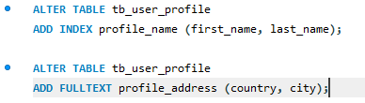

1. Tb_jobs



1. Create a backup script to backup the database every 6 hours with windows task scheduler

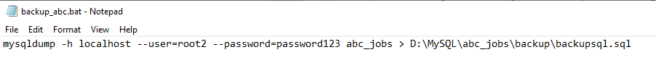

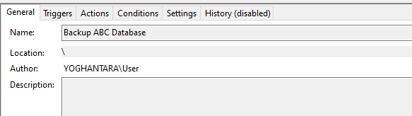

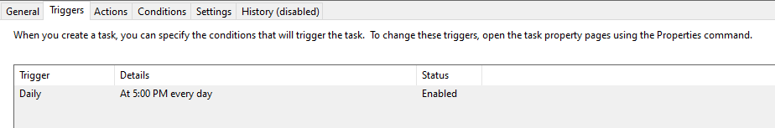

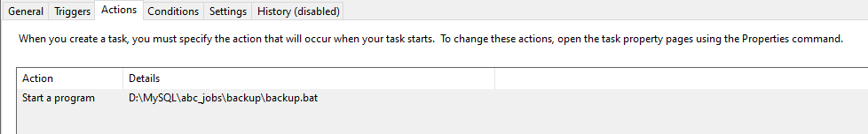

1. Task 6

Task Statement:

1. Create 8 SQL queries which will be used by the Community portal.
2. Import Sample data from CSV file in to the database.
3. Provide evidence of import as part of Project Presentation.

Solution:

Included in the Project Presentation.